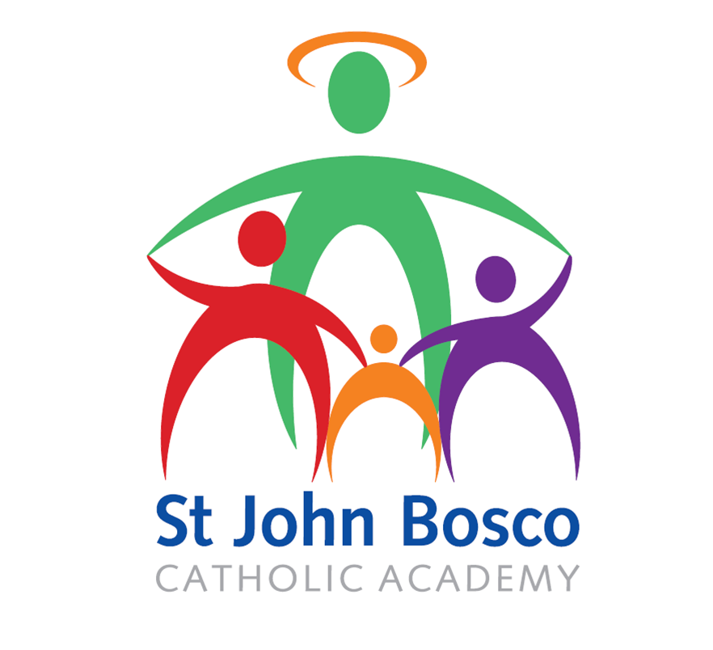

Safer Recruitment Policy

Approved: July 2022
Review: July 2024

Statement
It is everybody’s responsibility to take an active role in keeping all children safe.

In the St John Bosco Multi Academy, we are committed to offering quality Catholic education to the children, families and communities that we serve. Our core purpose as a company is to ensure that our schools provide caring, safe and distinctively Catholic environments within which every child can grow, learn and achieve.
We ensure that all children who attend or visit our schools feel safe and valued, unique in the image of Christ and that they can express any concerns they might have, that they feel listened to and that all appropriate action is taken when needed. We follow the most stringent of safer recruitment procedures. To deliver the highest standards of care, we work closely with all relevant external agencies, adhering to all local and national safeguarding guidance and procedures and in partnership with parents, carers and other colleagues within our community.
We provide a holistic, life enhancing and challenging faith-based curriculum in our schools to equip our children with the life skills they need to have safe and fulfilling lives.
Aims
1. To protect and prevent children from harm by deterring, rejecting or identifying those who are unsuitable to work with children and having the appropriate procedures in place
2. To ensure consistency in approach when seeking to identify the right person for a vacancy
3. To maintain and develop an on-going culture of vigilance and commitment to safeguarding children
4. To ensure staff are suitably trained as appropriate to ensure the importance of appointing staff reflects the importance of safeguarding children.
5. To support multi-agency working by taking the appropriate action and reporting those who may be deemed as unsuitable to work with children
6. To reduce the possibility of unsuitable people gaining an appointment at SJBCA

This policy should be read in line with the MAC SOP HR001 Recruitment of Staff

Responsibilities
All staff and Governors and those that engage with recruitment and selection activities on behalf of the MAC are responsible for ensuring they comply with and promote safeguarding of children through recruitment and selection. The policy covers staff, volunteers and contractors and any others who may be seen as a trustworthy source due to their presence in the MAC environment.

Principles

Advertising
On advertising the post, the advert will contain an explicit statement about the MAC’s commitment to safeguarding.

“We are committed to safeguarding and promoting the welfare of children; therefore, the post is subject to medical clearance and an enhanced DBS check.”

Application stage
Applicants pack prepared will contain: -
- Full job descriptions and person specifications
- Fair Deal for Applicants
- SJBCA Safeguarding Statement

Only applications submitted on the CES application form will be accepted. This will ensure that all applicants declare any spent or unspent criminal convictions at the application stage of the process.

Receipt of Applications

Short list Stage

Short listing will always be an activity undertaken by at least three to five people. At this point any concerns around application forms will be shared.

Applications forms will be scrutinised to identify any discrepancies / anomalies / gaps in employment.

These will be noted and further work undertaken if the candidate is considered for short listing.

All candidates will be assessed equally and consistently against the criteria in the Person Specification.

Where possible, recruitment activities will be organised to allow references to be obtained on shortlisted candidates prior to interview.

The MAC will obtain independent professional references directly from the referee that will answer specific questions to help assess an applicant’s suitability to work with children and following up any concerns. Open references will not be accepted as a substitute for a reference.

All references will seek for specific information relating to disciplinary offences relating to children including those where any sanctions may have expired (e.g. warnings that may not be used in new disciplinary hearings). The reference will seek information on whether the applicant has been subject to any child protection concerns and if so any outcome of any enquiry or disciplinary procedure.

Specific questions relevant to the post will be included for comment by the referee. These questions will challenge the application, times, dates and accuracy of submission.

A statement about liability of accuracy will be included.

References will be checked against the information provided on application forms.

Any matters raised on references will be noted and taken up with the applicant at interview.

If references have not been received before the interview, candidates will be asked if there is anything they wish to declare or discuss in light of what may be asked from a referee, and all references received will be scrutinised and checked against the information provided in the application form. Any matters raised on references received after interview will be taken up with the applicant prior to their appointment being confirmed.

Interview Stage

All applicants will be subject to an identity and professional qualifications check in all cases on arrival.

Comprehensive information will be obtained from applicants and any information provided by applicants that may have discrepancies or anomalies for example in the career history will be taken up with candidates with a view to resolve them to a satisfactory level.

A face to face interview will be undertaken with a panel of interviewers as the minimum tool to explore the candidates’ suitability for the post and to work with children.

There will always be at least two people interviewing of which one will have successfully completed the Safer Recruitment Training.

The panel will have discussed any issues arising from the application forms and references and the approach they intend to take to deal with them.

The interview will seek out the candidates’ suitability for the role in terms of skills along with the person’s attitude towards children, their ability to support the safeguarding agenda for the MAC, any gaps in employment history and concerns or discrepancies provided by the candidate or referee.

The panel will also ask the candidate if they wish to declare anything in light of the requirement for an Enhanced Disclosure & Barring Service (DBS) check

Offer of Appointment

On offer of appointment, references should have been received. If all references have not been received then offers of appointment will only be made conditionally.

A satisfactory Enhanced DBS check and satisfactory health clearance will be sought at the earliest possible stage and any offer of appointment will be made conditional to satisfactory reports.

All identity, qualifications and registration documentation will be confirmed they are in order along with the right to work in the UK.

An offer in writing will explicitly state the offer is subject to the above and the MAC’s commitment to safeguarding.

Post Interview

If a disclosure reveals information that a candidate has not previously declared during the course of the selection process, then further advice will be sought and the relevant DBS guidance will be followed.

If an applicant has provided false information on their application form, or the person has been disqualified from working with children or there are serious concerns about the applicants’ suitability to work with children, then the facts will be reported to the police and the Children’s Safeguarding Board, along with the Local Authority.
All overseas applicants will be subject to the same checks including DBS checks. Further advice will be sought from the DBS Overseas Information Service. In addition, a certificate of good conduct may be sought from the relevant overseas police force or embassy.

Verification that the candidate has the health capacity for the post will take place.

All newly appointed staff or volunteers will be required to familiarise themselves with the safe working guidance and will be subject to induction training, including safeguarding children. Existing staff will be required to undergo refresher training on a regular basis for safeguarding children. The purpose of the training will be to set clear expectations of what is required of them in terms of conduct, familiarise themselves with the MAC’s policies and procedures, clarify roles and responsibilities and enable the line manager or relevant person to address any concerns or issues immediately.

The content and nature of the induction programme will vary according to the individual. The safeguarding training at induction will aim to provide information about policies and procedures in relation to child protection, safe working for the protection of children and adults within the MAC, how and with whom any concerns can be raised and any other relevant policies e.g. Whistleblowing, Disciplinary and Capability

Existing Staff

If safeguarding concerns arise regarding an existing member of staff, a repeat DBS check
may be requested. If the MAC receives new information about a member of staff that suggests they are a risk to children the MAC will contact the relevant registered body(ies) and the local authority. The MAC’s disciplinary policy and procedure, and any other appropriate policy and procedure will be referred to if there are any concerns regarding the misconduct of a member of staff and if they are a potential risk to children.

Supply staff

All supply staff will be required to confirm any contractors supplied have undergone the
necessary checks for safeguarding children, namely identification, Qualifications, Enhanced DBS and references. On their first day to school, the contractor will be required to provide photographic identification as proof of their name and confirmation they are the person whom the supplying agency has sent. Any contractors sent from external agencies such as sports coaches, will need to provide confirmation that Enhanced DBS checks as a minimum have been conducted. An identification check will be undertaken on their first day on arrival to school.

Other local authority staff or volunteers

All centrally employed and Local Authority staff will not be subject to a separate Enhanced DBS check as this will have been carried out at the employing organisation. The academy will however conduct an identity check on their arrival to site.

Enhanced DBS checks will take place for all those who will have unsupervised regular access to children, and subject to certain exceptions, a list 99 check will be carried out as a minimum.

Volunteers expressing an interest to partake in regular work with the students at SJBCA will undergo a face to face interview with a representative from the academy. The appropriate procedure will be followed in conjunction with the YourHR and the line manager for the department the work is intended to take place in.

Monitoring

Recruitment and induction processes will be monitored to allow future practice to be better informed and will gather information on exit interviews and staff turnover including reasons for leaving and attendance to child protection training for new starters.

A single central record will be kept for each academy and maintained on all staff, contractors and volunteers who may have access to children. The record will contain the personal details of the individual, along with the checks that have been conducted on the individuals concerned. The information will be available to the Senior Leadership Team and MAC only.

